3. Research Proposal

FP-RESOMUS

Resolving Solvation with Molecular Ultrafast Science and Technology

Fellowship Program of the

NCCR MUST
National Competence Center for Research in
Molecular Ultrafast Science and Technology
&
Cluster of Excellence RESOLV

Project ID-No.:

The research proposal is a description of the research project and it is essential to carefully read the document “Guide for applicants” before continuing with your research proposal. It is important to keep in mind the format of the Research Proposal and to be familiar with the selection criteria that will form the basis for reviewers to evaluate the scientific merit of your research proposal.
Please follow the following layout for the preparation of the research proposal. Boxes should be expanded as needed. The maximum length of the research proposal is five (5) A4 pages. Please use the font type Arial with font size 11.

Title:

Abstract: Write a short abstract that summarizes the goals and anticipated outcomes (250 words; 0.5 pages).

Please note: Abstracts of granted projects will be published on the FP-RESOMUS web page and should not contain confidential information.

Keywords: Please provide up to three keywords from the ERC keywords list and up to five of your own choosing.

The ERC Keywords list can be found on the Guidelines webpage

Project Description: Develop a work plan in which research objectives, milestones and tasks, suitable experimental approaches are described. Include as well a feasibility analysis (2 pages).

References: Include between 7 and 10 key literature citations for your research project (0.5 pages).

Supervisor’s recommendation and comments: provide a short description how the applicant will be supported (matching funds) and which resources will be used for the project (0.5 pages).

Project Management Table: Prepare an overview table or Gantt-chart that depicts the milestones and main tasks over the project duration. Please identify at least 3 milestones, and 2 tasks per milestone. The table below has 6 project time periods (e.g., 0-4 months is one such interval) and your project should be presented with a similar time planning, between 4 and 6 time intervals.
Please use color coding to show the progression of the project over time (that is, Milestones and 3 are not reached at the same time), and dependencies (Milestone 3 depends on reaching Milestone 1).
An example of such a Table is given below. The font size can be Arial 8.

Goal of project:
 | Project month
 | 0-4 | 5-8 | 9-12 | 13-16 | 17-20 | 21-24
Milestone 1

Task 1
Task 2 (- Task X)
Milestone 2

Task 1
Task 2 (- Task X)
Milestone 3
(- Milestone X)

Task 1
Task 2 (- Task X)

One-page Project Overview: Prepare a one-page document (e.g. a Powerpoint slide) with sections: Aim, Outcome and Perspective to summarize your project. Also include a picture, diagram, photo, etc. to serve as visual representation of your research proposal. No more than 60 words are allowed for the areas below “Name” and “Title”.

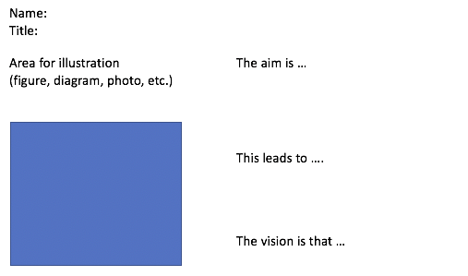

https://www.fp-resomus.ethz.ch/projects/

